Architectural Adaptation and Objective-Function Ablation of H-DenseUNet and MDU-Net for Classification
H-DenseUNet and MDU-Net were originally developed for image segmentation tasks. To adapt them to the binary classification task in this study, we preserved their principal feature-extraction pipelines as much as possible while modifying the output components accordingly. Specifically, the core encoding and feature-extraction modules were retained, whereas segmentation-specific decoding or output components that were no longer required for the final prediction were removed. Global pooling and fully connected classification heads were then introduced to produce two-class predictions. The retained modules, removed segmentation-related components, and newly introduced classification heads are illustrated in Fig. 1.
For the primary performance comparison, the modified H-DenseUNet and MDU-Net were trained using the same dual-modality ROI input and the same Asymmetric Loss (ASL) as our proposed method, thereby maintaining consistent input conditions and classification objectives across models.
In addition, we conducted an objective-sensitivity analysis to assess whether the change in optimization objective during the adaptation from segmentation to classification could introduce additional performance bias. Because voxel-level segmentation annotations were not available for the classification cohort, the original supervised segmentation losses could not be directly re-optimized on this dataset. Therefore, under otherwise matched data splits, network configurations, and training settings, we compared classification using ASL alone with classification using ASL together with a segmentation-oriented entropy regularization term. This auxiliary constraint was introduced to evaluate the sensitivity of classification performance to an additional segmentation-related optimization objective, rather than to reproduce the original supervised segmentation losses.
The corresponding results are reported in Table 1. The additional segmentation-oriented entropy regularization did not improve the classification performance of either modified baseline. Accordingly, ASL was consistently adopted for H-DenseUNet, MDU-Net, and the proposed method in the primary comparison to maintain a unified classification objective and facilitate a fair comparison.
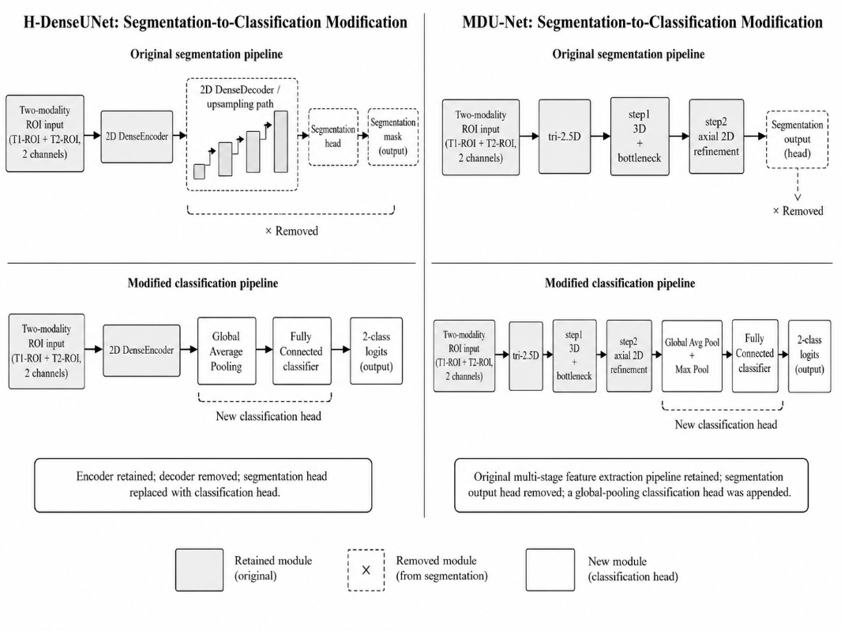
Fig. 1. Schematic illustration of the segmentation-to-classification adaptation of H-DenseUNet and MDU-Net.

Table 1. Performance comparison and objective-sensitivity analysis of the modified hybrid baselines.
Model | Input | Training Objective | mF1 (%) | mAccuracy (%) | mPrecision (%) | mRecall (%)
Twist3DNet | ROI | ASL | 75.8± 6.4 | 78.1± 8.2 | 78.9± 8.1 | 75.3± 6.2
H-DenseUNet | ROI | ASL | 70.0±8.7 | 72.3±9.4 | 70.9± 7.0 | 71.8± 11.1
MDU-Net | ROI | ASL | 63.8±10.8 | 68.9± 6.9 | 75.3± 5.8 | 68.1± 9.1
H-DenseUNet | T1 + T2 | ASL | 54.7±12.1 | 62.2±12.6 | 60.1±21.8 | 59.7±5.6
H-DenseUNet | T1 + T2 | ASL + 0.1 entropy reg | 43.5±11.3 | 61.4±11.4 | 45.5±23.2 | 53.5±4.8
MDU-Net | T1 + T2 | ASL | 57.3±12.9 | 68.2±12.4 | 62.0±14.1 | 60.7±10.5
MDU-Net | T1 + T2 | ASL + 0.1 entropy reg | 46.1±4.8 | 61.4±11.1 | 51.1±14.4 | 51.9±2.0

